The East Asia Morning Online Group of Alcoholics Anonymous

Meeting minutes April 30, 2021

Chair: James
Voting members: James, Craig, Dennis W., Les, Phil, Cho, Souad, Jenny, Julie, Paul
Guests: James Michael, Darren

Did the Serenity Prayer and read the 12 Traditions at the start.

May Service Positions (by acclamation):

Monday (Sunday):
> Chair = Julie
> Host = Chris

Wednesday (Tuesday):
> Chair = Jenny
> Host = Cho

Friday (Thursday):
> Chair = Paul
> Host = James

Next Business Meeting Chair:
> Chair = Dennis

Group Service Rep:
> Stuart is GSR ????? I think this is true, but I may be wrong

- Sec’y Report (we don’t really have a secretary, but old business was outlined)

- GSR report: Jenny and Stuart will handle. Next meeting May 9.

- Old business:

- Craig’s report:

Preparations for the new room have been completed by a large group of people mentioned below. Phil opened a new Skype chatroom and a new email to go with it. As of 4/28, 9 out of 9 folks were able to sign in with no problems whatsoever (Japan X 4, US X 2, Australia, China, and Korea one apiece). Phil, Jenny, James and I, all signed in. They organized the room and the notices, and five additional folks signed in: Julie, Chris, Paul, Cho, and Andy. James and Jenny have drafted announcements we can vote on. Souad has 3 options for the icon we can vote on. Jenny said she can handle the postings to the web page. The 5/9 Intergroup plan is down to Stuart and Jenny deciding how to do it. So, many hands make light work, and a big thank you to all who have helped.

- New business

- Craig will post the following announcement every meeting in May:
Information from East Asia Morning Online Group of AA

East Asia Morning Online Group of AA (currently meeting at Skype account “aaonlinemeeting – Room 1” on Monday, Wednesday, Friday 07:30 Japan/Korea time) will switch to the following Skype account starting from the meeting of Wednesday, June 2, 2021.

“EA aaonlinemeeting”

We kindly request that you send in a contact request to the EA aaonlinemeeting Skype account during the month of May so that you may have easy access to the account come June."

Meeting times and days will remain the same.

- Jenny will read the following announcement to Intergroup and the Digital Maintenance Committee:

"Please be advised that the Skype ID will be change to EA aaonlinemeeting as of June 1st, 2021."

As for Intergroup, it's being held on May 9th. I think a simple announcement such as the following would be fine:

"The East Asian Morning Group of Alcoholics Anonymous will be having meetings on their own Skype account, with the username of EA (space) aaonlinemeeting, effective June 1st. As some of your group members may occasionally join our meetings, we'd like to kindly ask that your groups be notified of the change as well."

- Souad presented 4 icons to vote on, and Option-1 was selected:

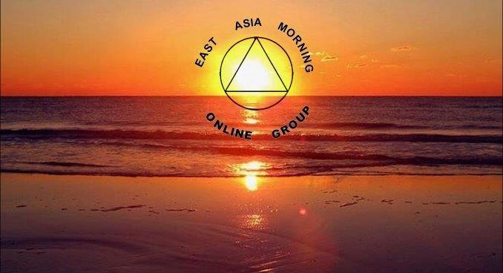

Ended with the Serenity Prayer.

Adjourned.

